Topikal Setara Daerah & Negeri [TOSDAN] 2016
Topik: Nisbah & Kadaran (Kertas 1)
Soalan 1 PPD Kuatan MT T6 Jun 2016 (No.7)
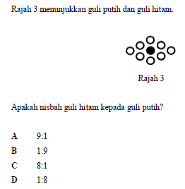

Soalan 2 PPD Keningau MT T6 Mei 2016 (No.7)
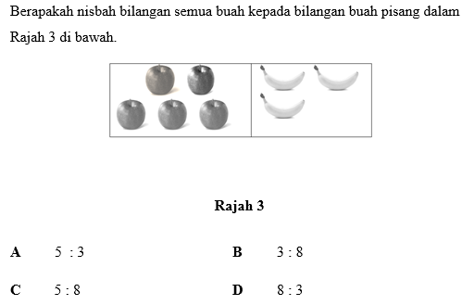

Soalan 3 JPN Terengganu AKRAM MT T6 BK 10 2016 (No.20)
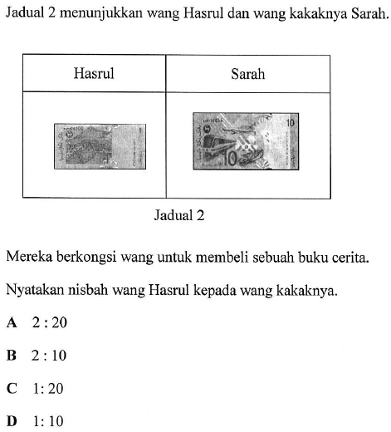
Soalan 4 JPN Terengganu AKRAM MT T6 BK 10 2016 (No.36)
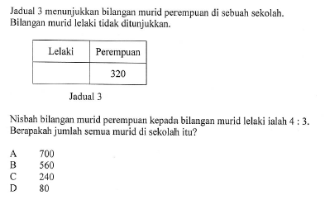

Soalan 5 PPD Simunjan MT T6 PPT 2016 (No.37)
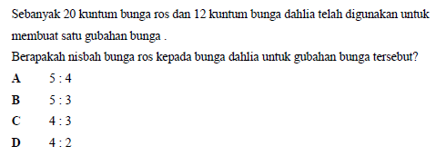

Soalan 6 PPD Sabak Bernam MT T6 PPT 2016 (No.10)
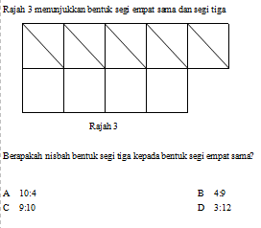
Soalan 7 JPN Johor UPPM 2 MT T6 PPT 2016 (No.14)
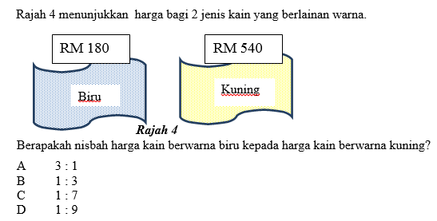
Soalan 8 JPN Kedah MT T6 Modul Think – Thank Set 5 2016 (No.7)
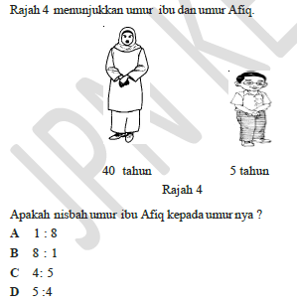

Soalan 9 JPN Kedah MT T6 Modul Think – Thank Set 4 2016 (No.33)
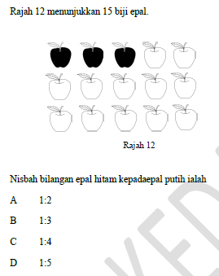

Soalan 10 JPN Kedah MT T6 Modul Think – Thank Set 3 2016 (No.7)
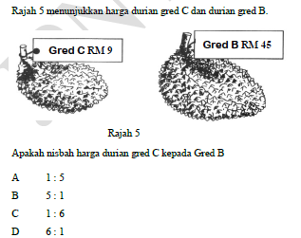

Jawapan:-
Soalan 1 | D | Soalan 11 |  | Soalan 21 |  | Soalan 31
Soalan 2 | D | Soalan 12 |  | Soalan 22 |  | Soalan 32
Soalan 3 | B | Soalan 13 |  | Soalan 23 |  | Soalan 33
Soalan 4 | B | Soalan 14 |  | Soalan 24 |  | Soalan 34
Soalan 5 | B | Soalan 15 |  | Soalan 25 |  | Soalan 35
Soalan 6 | A | Soalan 16 |  | Soalan 26 |  | Soalan 36
Soalan 7 | B | Soalan 17 |  | Soalan 27
Soalan 8 |  | Soalan 18 |  | Soalan 28
Soalan 9 |  | Soalan 19 |  | Soalan 29
Soalan 10 |  | Soalan 20 |  | Soalan 30

